**Outputs of Assignment 4-2:**

**Initial Output Screen for XML Transformation and XML Verification**

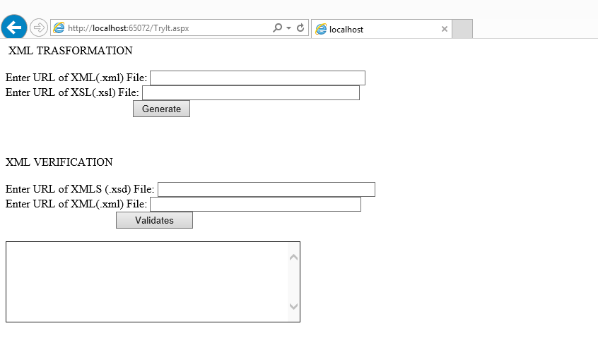

**Result of XML Transformation for file HotelXML.xml and Hotels.xsl**

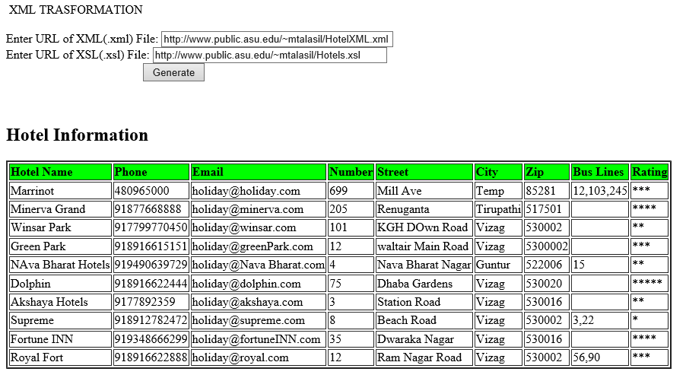

**No Error Output**

**For XML Verification of Hotels.xsd and Hotels.xml**

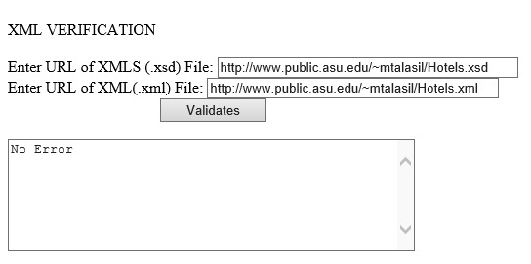

**Error Output**

**For XML Verification of Hotels.xsd and HotelTest.xml**

